Name :SK.Kashifa

Registration no :192121135

Gardener booking system :

Class diagram :

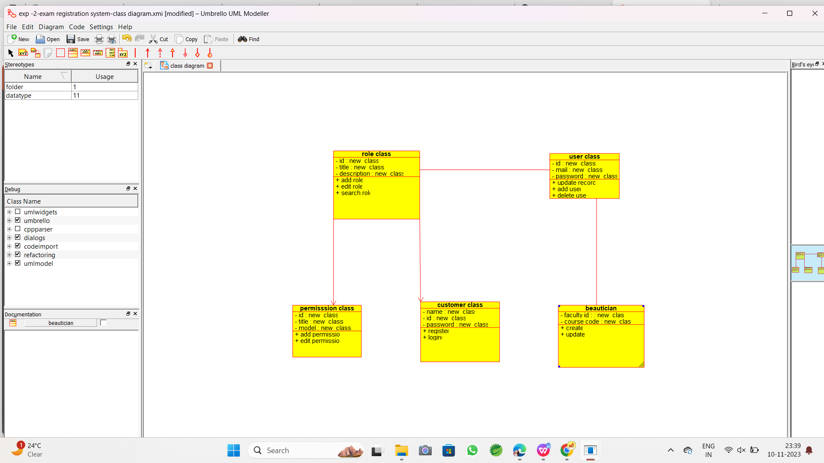

Use case diagram :

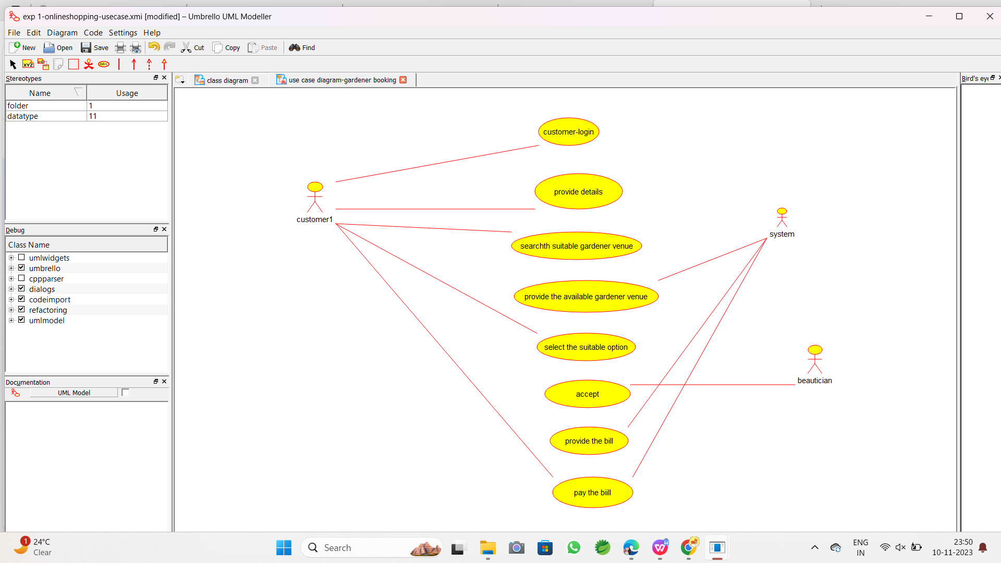

Deployment diagram :

